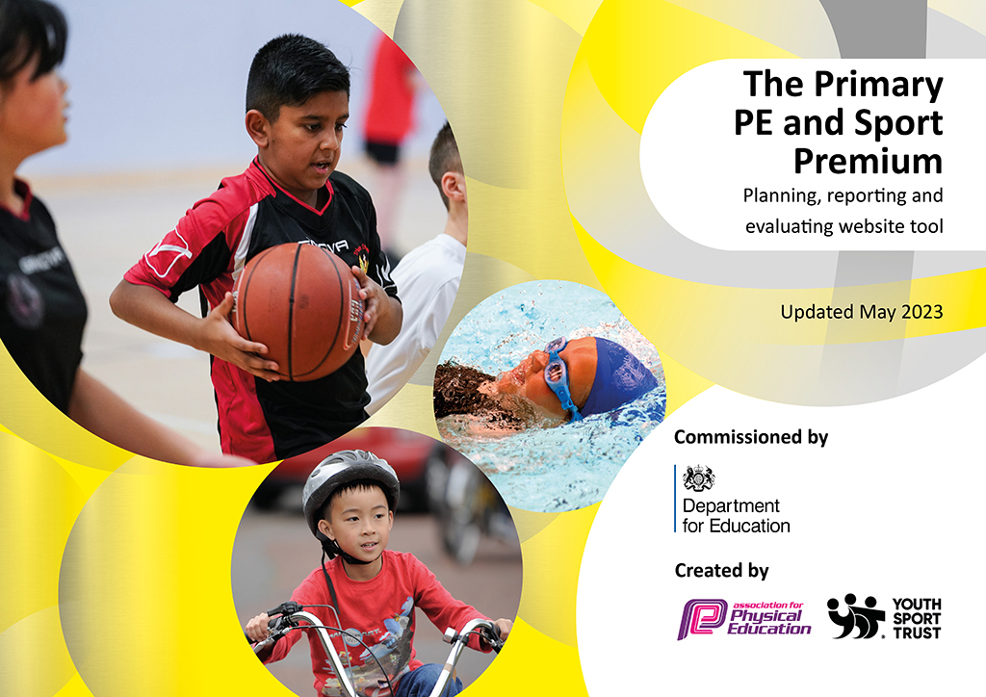
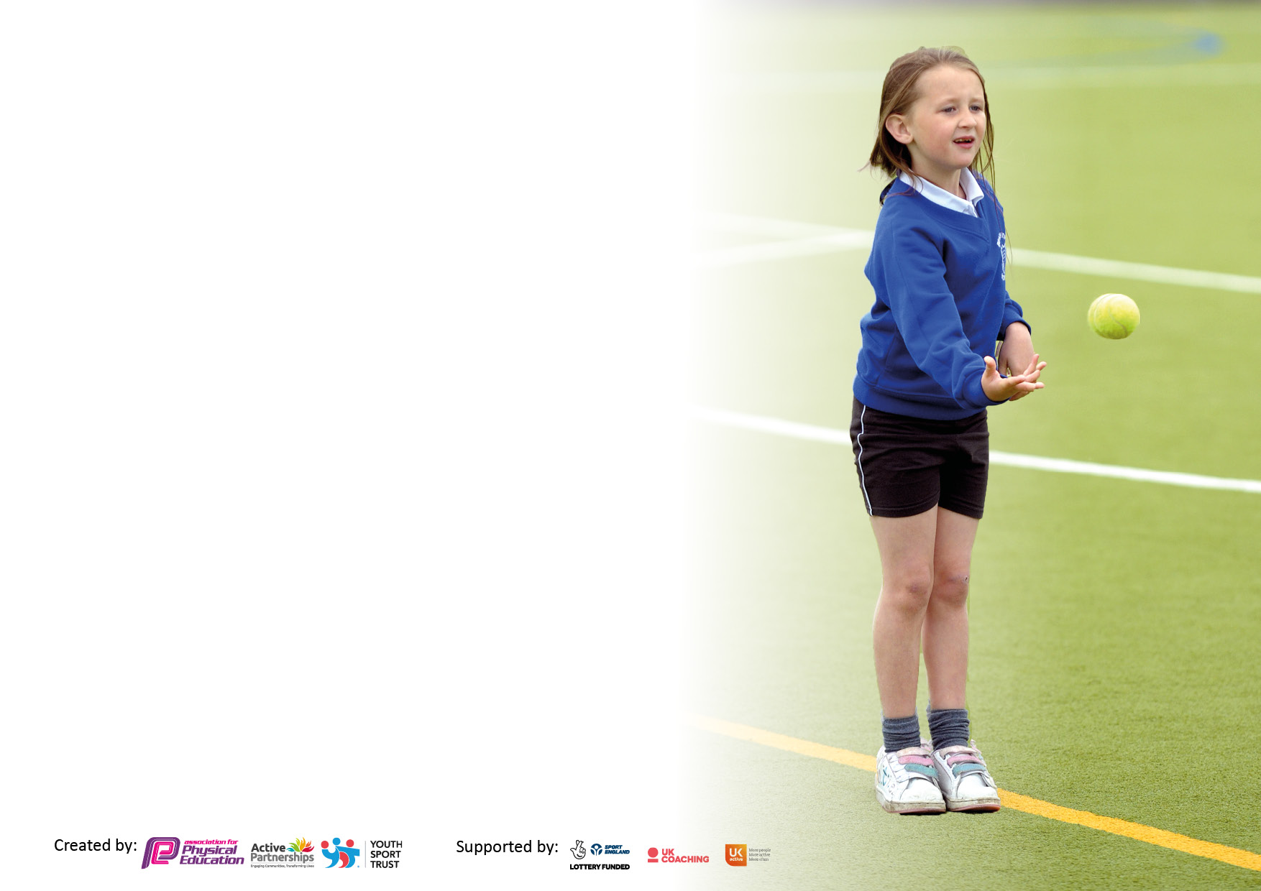

It is important that your grant is used effectively and based on school need. The Education Inspection Framework makes clear there will be a focus on ‘whether leaders and those responsible for governors all understand their respective roles and perform these in a way that enhances the effectiveness of the school’.

Under the Quality of Education Ofsted inspectors consider:
Intent - Curriculum design, coverage and appropriateness
Implementation - Curriculum delivery, Teaching (pedagogy) and Assessment
Impact - Attainment and progress

To assist schools with common transferable language this template has been developed to utilise the same three headings which should make your plans easily transferable between working documents.

Schools must use the funding to make additional and sustainable improvements to the quality of Physical Education, School Sport and Physical Activity (PESSPA) they offer. This means that you should use the Primary PE and sport premium to:

- Develop or add to the PESSPA activities that your school already offer
- Build capacity and capability within the school to ensure that improvements made now will benefit pupils joining the school in future years
- The Primary PE and sport premium should not be used to fund capital spend projects; the school’s budget should fund these.

Pleasevisitgov.ukfortherevisedDfEguidanceincludingthe5keyindicatorsacrosswhichschoolsshoulddemonstrate animprovement.Thisdocumentwillhelpyoutoreviewyourprovisionandtoreportyourspend.DfEencouragesschools to use this template as an effective way of meeting the reporting requirements of the Primary PE and Sport Premium.

We recommend you start by reflecting on the impact of current provision and reviewing the previous spend.

Schools are required to publish details of how they spend this funding, including any under-spend from 2021/2022, as well as on the impact it has on pupils’ PE and sport participation and attainment. All funding must be spent by 31st July 2023.

We recommend regularly updating the table and publishing it on your website throughout the year. This evidences your ongoing self-evaluation of how you are using the funding to secure maximum, sustainable impact. Final copy must be posted on your website by the end of the academic year and no later than the 31st July 2023. To see an example of how to complete the table please click HERE.

Details with regard to funding
Please complete the table below.

Total amount carried over from 2021/22 | £0
Total amount allocated for 2022/23 | £17,410
How much (if any) do you intend to carry over from this total fund into 2023/24? | £169
Total amount allocated for 2023/24 | £17,510
Total amount of funding for 2023/24. To be spent and reported on by 31st July 2024. | £17,679
Swimming Data
Please report on your Swimming Data below.

Meeting national curriculum requirements for swimming and water safety.

N.B. Complete this section to your best ability. For example you might have practised safe self-rescue techniques on dry land which you can then transfer to the pool when school swimming restarts.
Due to exceptional circumstances priority should be given to ensuring that pupils can perform safe self rescue even if they do not fully meet the first two requirements of the NC programme of study
What percentage of your current Year 6 cohort swim competently, confidently and proficiently over a distance of at least 25 metres?  N.B. Even though your pupils may swim in another year please report on their attainment on leaving primary school at the end of the summer term 2023.  Please see note above | 71%
What percentage of your current Year 6 cohort use a range of strokes effectively [for example, front crawl, backstroke and breaststroke]?  Please see note above | 71%
What percentage of your current Year 6 cohort perform safe self-rescue in different water-based situations? | 71%
Schools can choose to use the Primary PE and sport premium to provide additional provision for swimming but this must be for activity over and above the national curriculum requirements. Have you used it in this way? | Yes/No - £1500 for additional swimming sessions.

Action Plan and Budget Tracking
Capture your intended annual spend against the 5 key indicators. Clarify the success criteria and evidence of impact that you intend to measure to evaluate for pupils today and for the future.

Academic Year: 2022/23 | Total fund allocated: | Date Updated: July 2023
Key indicator 1: The engagement of all pupils in regular physical activity – Chief Medical Officers guidelines recommend that primary school pupils undertake at least 30 minutes of physical activity a day in school |  |  |  | Percentage of total allocation:
 |  |  |  | 48%
Intent | Implementation |  | Impact
Your school focus should be clear what you want the pupils to know and be able to do and about  what they need to learn and to  consolidate through practice: | Make sure your actions to achieve are linked to your intentions: | Funding allocated: | Evidence of impact: what do pupils now know and what can they now do? What has changed?: | Sustainability and suggested next steps:
The new trim trail has been made available to all year groups at break and lunchtimes.  Variety of play equipment available at play times to increase physical activity at playtimes.  Professional coaching across a variety of sports through the year. | All children are allowed to use the climbing wall every break and lunch.  Supervising staff ensure that all children have access to the trail if they wish to use it.  Play equipment monitors have been selected from Y5 to ensure a variety of equipment is accessible each day for children to use. They also have responsibility of ensuring the equipment is used correctly and looked after. Making sure it is put away safely each day.  Professional sports coach employed for one day per week to teach 5 classes on various sports. | £2,018  £250  £5,207 | Allowing continuous access to the trim trail has been particularly popular with our KS1 and LKS2 children - it has really supported their fine motor development, increasing the strength in their fingers. The equipment increases physical participation levels by engaging children in playful exercise.  Having a variety of play equipment available continues to increase physical participation at lunchtimes for all classes. It is a non-structured form of exercise which appeals to our children who are more reluctant to take part in any form of exercise.  Y1, 2, 3, 5 & 6 get high quality coaching once a week from the coach. | To continue to allow open access from all classes to use the trim trail.  To set mini challenges for the equipment to increase children’s enthusiasm to join in. E.g Skipping competition, who can do the most skips in a row?
Key indicator 2: The profile of PESSPA being raised across the school as a tool for whole school improvement |  |  |  | Percentage of total allocation:
 |  |  |  | 48%
Intent | Implementation |  | Impact
Your school focus should be clear what you want the pupils to know and be able to do and about  what they need to learn and to  consolidate through practice: | Make sure your actions to achieve are linked to your intentions: | Funding allocated: | Evidence of impact: what do pupils now know and what can they now do? What has changed?: | Sustainability and suggested next steps:
Forest School continues to be a wonderful opportunity for our Reception children to participate in outdoor experiences that involve physical activity.  Bikeability | Purchase necessary equipment to keep Forest School running. Pays Forest School practitioner.  Year 5 pupils take part in Level 1&2 of Bikeability to build their understanding of safety whilst riding a bike on the road. | £7,566 | Reception participated in Forest School sessions every Friday morning for the whole academic year.  The children’s confidence increased with how to ride safely and are now more motivated to go on bike rides outside of school. | To continue to provide weekly sessions for Reception.  To book Bikeability for the Y5 cohort again for Spring 2024.

Key indicator 3: Increased confidence, knowledge and skills of all staff in teaching PE and sport |  |  |  | Percentage of total allocation:
 |  |  |  | 4%
Intent | Implementation |  | Impact
Your school focus should be clear | Make sure your actions to | Funding | Evidence of impact: what do | Sustainability and suggested
what you want the pupils to know | achieve are linked to your | allocated: | pupils now know and what | next steps:
and be able to do and about | intentions: |  | can they now do? What has
what they need to learn and to |  |  | changed?:
consolidate through practice:
Buy into another yearly subscription of the GetSet4PE scheme to ensure clear progression through years, to secure subject knowledge and coverage. | Teachers who are teaching their class PE to use the GetSet4PE lesson plans, videos, sequence of learning to deliver a high – quality PE lesson.  All sports coaches to also use the GetSet4PE plans, but adapt these to again ensure coverage, progression and consistency.  Ensure consistent assessments are made using the system linked to the scheme we follow to provide a clearer understanding of which children are ‘working towards’, ‘expected’ and ‘exceeding’. | £700 | Teachers that have taught PE this year have been able to deliver a good PE lesson through the use of a well – planned/sequenced lesson that has provided them with the subject knowledge required. The children have had a variety of different skills/games taught this year with key vocabulary and were able to progress through each lesson, building on previously taught skills. | Continue to buy into GetSet4PE to ensure consistency, progression and provide teachers with subject knowledge.  To allocate some of the spending for CPD for our teachers with our sports coaches so that the teachers that will be teaching PE next year have some allocated time to spend with our sports coaches to help upskill them with subject knowledge and skill progression.  Assessments to be shared between coaches and cohorts so that class teachers are aware of the children’s ability.
Key indicator 4: Broader experience of a range of sports and activities offered to all pupils |  |  |  | Percentage of total allocation:
 |  |  |  | <1%
Intent | Implementation |  | Impact
Your school focus should be clear | Make sure your actions to | Funding | Evidence of impact: what do | Sustainability and suggested
what you want the pupils to know | achieve are linked to your | allocated: | pupils now know and what | next steps:
and be able to do and about | intentions: |  | can they now do? What has
what they need to learn and to |  |  | changed?:
consolidate through practice:
Additional achievements:  A range of afterschool clubs available at least 2 days per week.  100% Sports day participation | Weekly after-school clubs provided for all pupils KS1/2. Prestige coaches provide 2 afterschool clubs each week, changing the sporting activity termly to allow exposure to a range of sports.  Share sports day events with coaches and teachers prior to the event so that the children can practice building the children’s confidence and skills |  | Each term, the clubs changed to allow a variety of different sports activities which meant there were different children joining each term. Not only did this promote extra fitness time but also the ability to develop skills taught in school and work as part of a team.  All children (EY-Y6) participated in physical activities for an entire school day with much enjoyment. Y6 children also got to lead the events to practice their leadership skills. | To continue with weekly afterschool clubs, using Prestige coaches. Possible pupil perception to help decide on what clubs to run so that we are getting a range of children attend and not just the regular children.  To use a carousel approach of activities again next year to expose children to more activities.

Key indicator 5: Increased participation in competitive sport |  |  |  | Percentage of total allocation:
 |  |  |  | <1%
Intent | Implementation |  | Impact
Your school focus should be clear | Make sure your actions to | Funding | Evidence of impact: what do | Sustainability and suggested
what you want the pupils to know | achieve are linked to your | allocated: | pupils now know and what | next steps:
and be able to do and about | intentions: |  | can they now do? What has
what they need to learn and to |  |  | changed?:
consolidate through practice:
No participation in competitive sport this year - something to improve on moving forwards.

Signed off by
Head Teacher:
Date:
Subject Leader: | Luke Howden
Date: | 17.07.23
Governor:
Date:

