Spring Term
Monday 9th January 2023
Hello and a very happy New Year to you all. We hope you had a wonderful Christmas time. Thank you so much for the kind cards, messages and gifts; we are all truly grateful. Also, a big welcome to Lillie who has just started in our class. The children are making her feel very welcome!
I thought now would be a good time to update you on all of the things we will be covering in Year 1 over this coming spring term.

English Writing
In our English writing lessons we will continue to focus on calligrams, shape poetry and creating our own poems. We will also be focusing on writing informal letters, as well as writing a recount and looking at stories with familiar settings.

English Reading
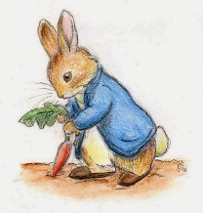
We will continue to have our twice-weekly reading lessons, which are currently Aesop’s Fables – The Boy Who Cried Wolf, followed by The Tale of Peter Rabbit. We will be using our predicting, summarising and retrieval skills to answer questions about what we have read.

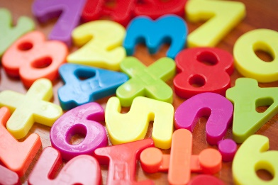
Maths
Our current area of focus in maths is place value within 20, moving on to within 50 later in the term. We will be using number lines and apparatus to help us to solidify our learning. We will also be learning about length and height as well as mass and volume.

Science
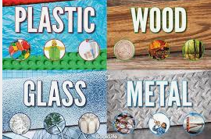
Our new science topic, for the first half-term, is ‘Everyday Materials’. We will be focusing on different types of materials and what properties they have. We will also be experimenting with materials, to find out whether they are waterproof and which of them are transparent or opaque. After the half-term break, we will revisit and continue to learn about animals, including humans.

History and Geography
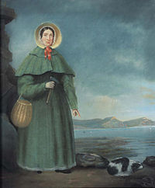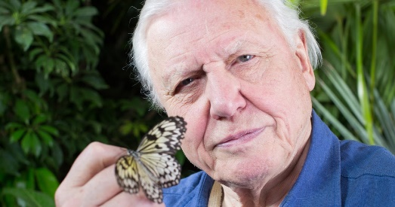

Currently in geography, we are learning about the four countries that make up the United Kingdom and we will also be focusing on capital cities. In history, in a few weeks, we will be looking at the lives of significant people; including Mary Anning and Sir David Attenborough.
Other areas of learning
In art, we are just starting our printmaking lessons. Later this term, we will be learning about textiles and, in PSHE, we are looking at health and wellbeing. In RE our focus is Jesus as a friend.

Another busy term ahead of us, with lots of interesting and exciting things to learn.

Take care and thank you for your continued support.

Our best wishes

Mrs Laxton and the Year 1 Team

